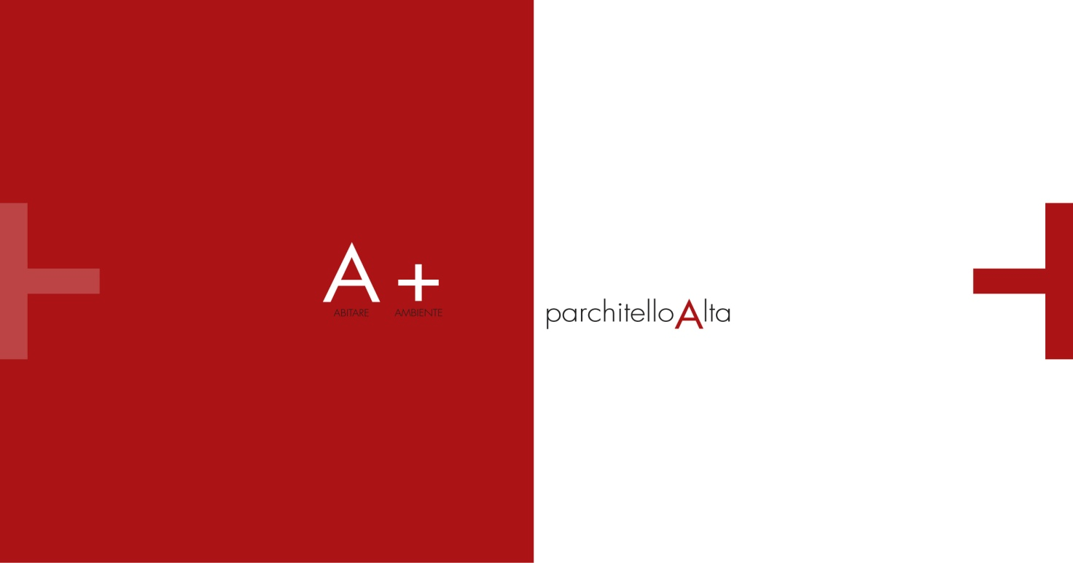

Performance specifications

“The Apartments”

Revision date: 21/12/2012
Giem srl

“PARCHITELLO ALTA” HOUSING ESTATE
Table of contents
INTRODUCTION ....................................................................................................................................... 4
ARCHITECTURAL PROJECT……….............................................................................................................. 4
PERFORMANCE SPECIFICATIONS............................................................................................................. 5
1. GEOLOGICAL STUDIES…. ......................................................................................................... 5
2. LOAD-BEARING STRUCTURES.................................................................................................. 5
3. EXTERNAL INFILL WALLS…………. ............................................................................................. 5
4. INSULATION............................................................................................................................. 6
4.1. Thermal insulation................................................................................................................... 6
4.2. Acoustic insulation.................................................................................................................. 6
4.3. Roof waterproofing and insulation…………………………… .......................................................... 6
5. COATING AND EXTERNAL FLOORING – BALCONIES AND TERRACES...................................... 6
6. DOORS AND WINDOWS FRAMES............................................................................................ 7
7. INTERNAL WALLS AND FALSE CEILING…..…............................................................................. 7
7.1. Partition wall separating residential units............................................................................... 7
7.2. Internal Counterwalls…............................................................................................................ 8
7.3. Partitions ................................................................................................................................. 8
7.4. False ceilings ………................................................................................................................... 8
8. INTERNAL DOORS…................................................................................................................. 8
9. SECURITY DOOR………………...................................................................................................... 8
10. FLOORS AND COVERING…….................................................................................................... 9
10.1. Internal floors…....................................................................................................................... 9
10.2. Bathroom and laundries covering.......................................................................................... 9
11. BATHROOM SUITES, TAPS AND FITTINGS.............................................................................. 10
12. PAINTING AND VARNISHING………......................................................................................... 11
13. TECHNOLOGICAL SYSTEMS.................................................................................................... 12
13.1.1 Photovoltaic system…............................................................................................................ 12
13.1.2 Thermal solar system…… ....................................................................................................... 12
13.2. Mechanical plants. ................................................................................................................ 13
13.2.1 Heating system…………..…….................................................................................................... 13
13.2.2 Air-conditioning system………................................................................................................. 14
13.2.3 Plumbing and sanitary system............................................................................................... 14
13.2.4 Sewerage system................................................................................................................... 14
13.3. Electrical and special systems................................................................................................ 15
13.3.1 Grounding system.................................................................................................................. 15
13.3.2 Electric panels ........................................................................................................................ 15
13.3.3 Lighting system and f.m. ....................................................................................................... 15
13.3.4 Burglar alarm and automation ……………................................................................................ 16
13.3.5 Telephone system ….............................................................................................................. 16
13.3.6 TV system …........................................................................................................................... 16
13.3.7 Video entry-phone system.................................................................................................... 16

14. CELLARS AT DISPOSAL OF THE APARTMENTS....................................................................... 16
15. MAIN ENTRANCE AND STAIRWELL ........................................................................................ 17
16. COMMON GARDENS………….................................................................................................. 17
17. ROOF WATER COLLECTION............... .................................................................................... 17
18. SPECIAL NOTES ……................................................................................................................. 17
19. MANAGEMENT OF COMMON PARTS.................................................................................... 18

“PARCHITELLO ALTA”HOUSING ESTATE
provided with Class A Energy Attestation and Certification

INTRODUCTION
“Parchitello Alta” is an initiative of GIEM Srl with main office in Bari, at the address via Piazza Eroi del Mare n. 5.
For many years now, GIEM has been involved in the promotion, design and building of important estates for the residential, tertiary managerial and business sector in Apulia and in particular in Bari.

“Parchitello Alta” project, situated in the town of Noicattaro, has been designed by taking into consideration several goals that GIEM considers as operational priorities:
• High functionality
• Extreme comfort
• Privacy and independence
• Refined setting
• Use of energy-saving technologies and building systems

ARCHITECTURAL PROJECT
The choice has been made by taking into consideration a residential area situated in a well-established urban background that was able to support the achievement of the goals mentioned above.
The housing estate is situated in the town of Noicattaro. It is accessible from the municipal road Coppe di Bari and it is adjacent to “Parchitello” housing estate.
It has particular environmental and urban characteristics that guarantee high quality standards in a high-value urban setting.
The housing estate is developed over an area of 95,000 m2 and it is constituted by:
• 48 single-family mansions (“The Villas”) on independent lots of approximately 1,000 m2 each. Within each pertinence lot, every mansion is provided with private garden and parking areas for two cars.
The Villas are divided into 7 different types, each having a basement and a ground floor.
Two out of seven have also a first floor. Since the villas are independent real estates of diffuse type, common passages are constituted by a suitable vehicular, pedestrian and cycling system.
• 63 apartments (“The Apartments”) are spread over four buildings, each of which is constituted by a basement, a ground floor, a first and a second floor.
Three of these buildings are constituted by two staircases while the fourth one by a single staircase. All the estates are independent. The only parts they have in common are the stairwells and the lift which lead to the apartments and to the cellars situated in the basement.
Furthermore, the apartments on the ground floor are provided with private garden and loggias, while the ones on the first and second floor are provided with terraces and balconies.

PERFORMANCE SPECIFICATIONS

1. GEOLOGICAL STUDIES
As precaution, the target area has been subjected to geological studies. The works of structural nature and the building system are planned on the basis of the data collected during the study phase.

2. LOAD-BEARING STRUCTURES
Buildings’ load-bearing structures are made of reinforced concrete and have been built in compliance with the drawings of the works in reinforced concrete.
They are dimensioned to withstand transient overloads in the practicable areas (200 kg/m2: villas and apartments, 400 kg/m2: staircases, balconies and terraces).

3. EXTERNAL INFILL WALLS
In order to guarantee the maximum heating and acoustic efficiency of the dwelling units, in addition to the high quality level of the finishes and the greatest maintenance flexibility, all the external infill walls, partition walls and false ceilings are made with KNAUF metal frame system and coating of covered plaster plates.

KNAUF AQUAPANEL OUTDOOR Metal frame infill walls and reinforced concrete plate coating – Total thickness: 370/390 mm.
The external metal frame is made of a parallel double series with KNAUF series E profiles in ALUZINK zinc- and aluminium-coated steel of thickness 8/10 with U-shaped rails 150X40 mm. and uprights 150X50X0,6 mm. placed at a centre distance of 40 cm. and insulated from the perimeter structures with KNAUF 3,5 mm thick monoadhesive vinyl tape with function of acoustic insulation.
The internal metal frame is made with zinc-coated steel profiles with U-shaped rails 100X40 mm. and uprights 100X50 mm. placed at a centre distance of 60 cm and insulated from the perimeter structures with KNAUF 3,5 mm thick monoadhesive vinyl tape with function of acoustic insulation.
The external side covering of the external frame is made with a KNAUF AQUAPANEL OUTDOOR waterproof reinforced concrete panel with high mechanical strength. The internal side of the external frame is made with two KNAUF A(GKB) covered plasterboards of 12,5 mm. each.
The internal side covering of the internal frame is made with two panels of 12, 5 mm. each: the first one is a KNAUF A (GKB) fair-faced plasterboard, provided with aluminium foil vapour barrier, the second one is a KNAUF VIDIWALL XL fibre plasterboard.
In order to confer to the wall a suitable performance in terms of thermal and acoustic insulation, three insulating panels are inserted inside the two frames:
• External frame: two mineral wool panels, respectively of 100 mm thickness with 100 kg/mc density and 40 mm thickness with 50 kg/mc density.
• Internal frame: one mineral wool panel with 80 mm thickness and 50 kg/mc density.
On the internal side: final smoothing and painting
On the external side: final smoothing for a thickness of at least 5 mm with AQUAPANEL EXTERIOR BASECOAT plaster, reinforced with fibreglass net and painting or stone or marble covering in accordance with the designer’s drawings and choices.

4. INSULATION

4.1. Thermal insulation
All vertical and horizontal opaque structures have been designed in order to guarantee the limit energy demand established by the Legislative Decree 311/2006 and subsequent integrations of the Regional Law no. 10/2010.
As far as the laying, the quality, the thicknesses and the type of material to use are concerned, all the indications and the provisions resulting from the report and from the calculations drawn up in accordance with the law no. 10 dated 09/01/91 and subsequent modifications on energy consumption containment, which is attached to this document, will be strictly followed.

The energy certification of the building is expected to be released in accordance with the Regional Council deliberation no. 1009/2010 and with the resolution no. 8/2010 of the Spatial Planning Service.

4.2. Acoustic insulation
The acoustic requirements are verified in order to guarantee the acoustic well-being as well as a good quality of life. The work is made in order to keep the noise, detectable by the residents and by the people in the surrounding area, at such a level that it can guarantee satisfactory sleep, rest and work conditions. The technical requirements will refer to
- Prime Minister Decree 5/12/97 concerning the observance of building passive acoustic requirements.

4.3. Roof waterproofing and insulation
Roofs will be insulated and waterproofed with the SARNA exposed roof package composed by:
• vapour barrier layer constituted by a SARNAVAP 1000 E low-density polyethylene sheet with thickness of 0,20 mm, dry laid on a slope block sealed with double-sided tape;
• mechanically locked sintered foam polystyrene insulation board of thickness 90 mm;
• SARNAFIL TS 77 synthetic watertight facing made of an alloy of flexible polyolefin (FPO), with a polyether mesh and glass fibre composite scaffold with high mechanical strength. It is a non-prelaminated single layer facing, UV ray-resistant, with thickness of 1,8 mm, obtained in a single layer. It is dry laid and mechanically locked in place by the SARNAFAST system through the overlapping of hot air welded sheets of 12 cm at least. Along the horizontal part, the perimeter and the protruding bodies a mechanical fastening will be made by using a SARNABAR steel bar, suitable fastening elements and an anti-tear edging. Vertical welts made of polyolefin watertight facing could be entirely glued or mechanically locked in accordance with the HELIOS system.

5. COATING AND EXTERNAL FLOORING - BALCONIES AND TERRACES
The external parts of the buildings are characterized by the following finishes:
• External covering as indicated by the designer.
• Aluminium and crystal sheet parapets as indicated by the designer.
• Balconies and terraces are paved with RAGNO Transit series paving for outdoor use in iron colour, size: 15 x 15. Frost-resistant, R10.
• A base of the same type of the floor and of size 7 x 30 will be placed on the external walls in contact with the balconies.

6. DOORS AND WINDOWS FRAMES
All doors and windows frames are made of aluminium and are of the type Metra NC 65 STH with Thermal break. They can be swing and/or lift-sliding of alloy 6060 (UNI 3569) and are characterized by an open-joint tightness system, series standard painting of designer’s choice colour. All doors and windows frames have the following characteristics:
• Sections for doors and windows made of EN AW 6060 (EN 573-3 and EN 755-2) aluminium alloy with UNI EN 515 physical state of supply.
• Fixed frames and moving shutters are made with three-room heat bridge interruption sections.
• Windows and French windows have a fixed frame section with a depth of 65 mm and a moving shutter section of 75 mm.
• All doors and windows frames are made of elastomer (EPDM).
• Double glazing sealing is made of laminated internal slab 33.1
Low-E glass + 18 mm double glazing with hot interlayer + 33.1 external slab
Stratophone (noise filtering).
• Original accessories from Metra system.
• Windows and doors frames are permeable to air, waterproof and wind resistant in accordance with 2010 regulations.
Doors and windows frames are provided with insulated aluminium blackout shutter, with expanded polyurethane, fully equipped with electric handling accessories.
The shutter is located in a ISO 311 prefabricated shutter box, made of high-density polystyrene. On the external wall there is an aluminium frame with gasket for the application of two side covers, one of which is made of a fibre cement and polystyrene panel (which is wind tight, partially effective for thermal insulation and noise reduction); the other one is made of a sound insulating mat, polystyrene and fibre cement panel (effective for the achievement of thermal insulation and noise reduction).

7. INTERNAL WALLS AND FALSE CEILINGS
In order to guarantee the same comfortable conditions that are given by the insulation system, partition walls and false ceilings are also made by using the KNAUF system.

7.1. Partition wall separating residential units
Internal partition wall with double metal frame and coating in KNAUF covered plasterboards with sound-insulating power Rw=61 dB – Total thickness: 200 mm.
The metal frame is made of a parallel double series with KNAUF series E profiles made of zinc-coated steel with U-shaped rails 75X40X0,6 mm. and uprights 75X50 mm. placed at a centre distance of 60 cm and insulated from the perimeter structures with KNAUF 3,5 mm thick monoadhesive vinyl tape with function of acoustic insulation.
In order to confer to the wall a suitable performance in terms of thermal and acoustic insulation, two ISOVER insulating stone wool panels (60 mm thick) are inserted inside the two frames.
The covering on one side of each frame is made of two 12,5 mm sheets: the first one is a KNAUF A (GKB) fair-faced plasterboard, the second one is a KNAUF VIDIWALL XL fibre plasterboard.
A KNAUF A (GKB) plasterboard plate is situated between the two structures.
Final smoothing and painting.

7.2. Internal counterwalls
Internal counterwalls with metal frames and coating with KNAUF plasterboard plate.
The metal frame is made of KNAUF series E profiles in zinc-coated steel with U-shaped rails 28X30 and uprights 50X27 mm. placed at a centre distance of 60 cm and distanced from the wall by appropriate hooks and accessories.
The coating of the frame is made with a KNAUF DIAMANT 12,5 mm sheet. Final smoothing and painting.

7.3. Partitions
Wall with sound-insulating power Rw=54 dB, with metal frame with KNAUF series E zinc-coated steel structure with U-shaped rails 75X40X0,6 mm and uprights 75X50X0,6 mm placed at a centre distance of 60 cm. It is insulated from the perimeter structures with KNAUF 3,5 mm thick monoadhesive vinyl tape with function of acoustic insulation.
On each side of the structure two KNAUF A (GKB) 12,5 mm plasterboard sheets will be fixed and a ISOVER 60 mm thick glass wool panel will be interjected.
Total thickness of the wall 12,5+12,5+75+12,5+12,5 = 125 mm. Final smoothing and painting.

7.4. False ceilings
In order to guarantee the maximum heating and acoustic efficiency, as well as an effective and simple maintenance of the dwelling unit, a false ceiling will be built over all the ceilings in the rooms using the KNAUF metal frame and covered plasterboard panelling system.
The metal frame is made of a KNAUF series E zinc-coated steel structure with U-shaped rails 27X30X0,6 mm fixed to the floor and ceiling and C PLUS profiles 50X27X0,6 mm, placed at a centre distance of 50 cm in primary and secondary frame. Ceiling and floor rails are insulated from the masonry with KNAUF 3,5 mm thick monoadhesive vinyl tape with function of acoustic insulation.
The frame covering is made with KNAUF A (GKB) 12,5 mm. plasterboard sheets.
Final smoothing and painting.

8. INTERNAL DOORS
Internal doors will be provided by Ebanisteria De Bartolo (De Bartolo cabinet maker’s shop) and made with a bee hive patterned hollow core fir-wood structure, joined with 6 mm mdf with a total thickness of 47 mm and a highness of 210 cm, finished with oak or lacquered wood, having a perimeter edge made of thick solid wood. Doors are provided with finishing cornices, escutcheons, handles and door closer:
• Sliding door made with ribbed processing or with oak horizontal grain.
• Swing door made with ribbed processing or with oak horizontal grain.
• Sliding door with lacquered finishing and colour of your choice.
• Swing door with lacquered finishing and colour of your choice.

9. SECURITY DOOR
The entrance door will be an armoured single-swing door with foldaway hinges and key lock, provided with smooth internal covering, uniform with the internal doors. The external covering is made in accordance with the designer’s drawing and it is provided with secondary frame, frame and perimeter profiles of the door made of 20/10 galvanized sheet, while the armour plate and the reinforcing staves are made of 15/10 galvanized sheet. All these elements are painted with epoxy powder in the colour chosen by the designer.

The hinge side, both of the frame and of the leaf, is press-formed so as to assume a tear-proof system on the whole height.
The door is equipped with 3 drop-shaped hinges (per leaf) made from steel and hinges made from brass with a 12mm diameter and complete with bearings to facilitate the opening and the closure.
Omega Plus Esety lock type - triple map; on the lock side there are 11 points of
fastening.
Anti-draught bar or alternatively a fence fixed to the floor.

10. FLOORS AND COVERING

10.1. Internal floors
The interior spaces are floored with one of the following solutions, according to choice, as for sampling:
• Interior flooring in "pre-polished" wood with three-layer oak planks with 14 mm thickness and sizes 140/150 x 1500/1800 mm, laying with dry polishing and subsequent primer to the floor rough, two-component adhesive and water or oil finishing polishing. In case of oak, possibility of "finishing and colouring" the wood final layer.

10.2. Bathroom and laundries covering
The bathrooms coating is made with one of the following solutions, according to choice, as for sampling:
• marble, choosing among Brown Bulgari type, veined White America type, Travertino Ivory type and White Sivec type with a thickness not exceeding 20 mm and sizes no bigger than 110x40 cm slabs.

The coating will be placed at a height of cm. 110 only for the equipped wall, besides the inner lining of the shower compartment that will be placed at a height of cm 220.

11. BATHROOM SUITES, TAPS AND FITTINGS
The bathroom suites are supplied with one of the following solutions, according to choice:
• IDEAL STANDARD – Connect series
Flushing wall-hung toilet bowl with wall drain equipped with seat.
One-hole wall-hung bidet with tap water supply.
Washbasin with semi-column and wall mounting.
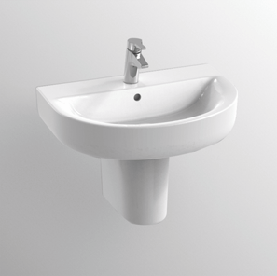

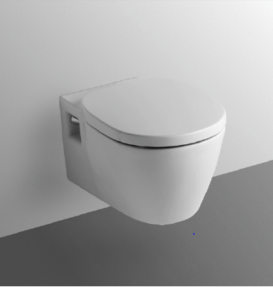
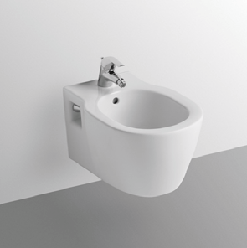

• DURAVIT – STARCK III series
Flushing wall-hung toilet bowl with wall drain equipped with seat.
One-hole wall-hung bidet with tap water supply.
Washbasin with semi-column and wall mounting.

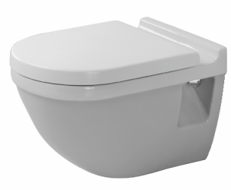
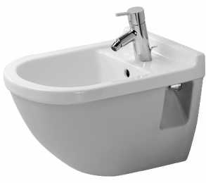

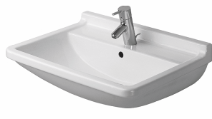

• DURAVIT – ARCHITECT series
Flushing wall-hung toilet bowl with wall drain equipped with seat.
One-hole wall-hung bidet with tap water supply.
Duraplus washbasin with wall mounting.

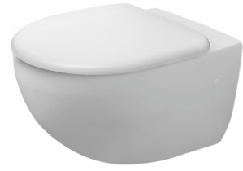
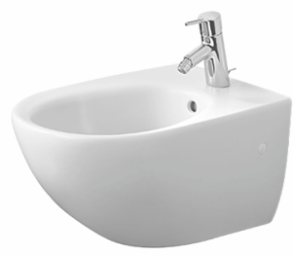

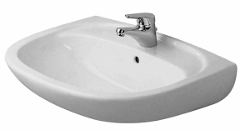

The water drain tank will be of the type:
• Geberit Series SIGMA / BOLERO

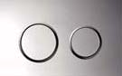
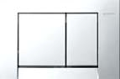

The taps and fittings are supplied with one of the following solutions, according to choice:
• ZAZZERI – MOON series
• ZAZZERI – SOQQUADRO series

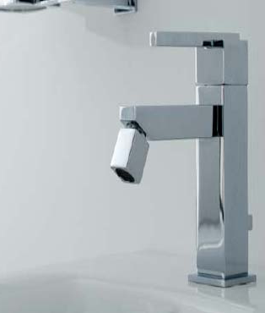

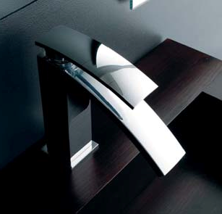
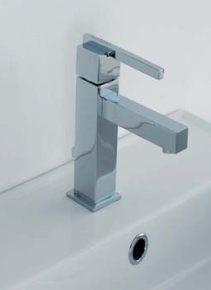

The shower heads are supplied with one of the following solutions, according to choice:
• BOSSINI – shower arm with head ∅ 20
• BOSSINI – Brass dupplex kit, chrome round bar 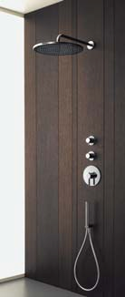

The shower trays are supplied with the following solution:
• Size 120x80: TEUCO – WILMOTTE series with high-flow drain kit and glass doors;
• Size 80x80: IDEAL STANDARD – ULTRAFLAT series with drain kit and
shower swing door for niche Novellini type mod. Giada Cromo with
door system.

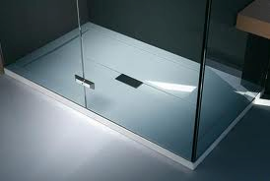

12. PAINTING AND COATING
Interior and exterior painting and coating will be made with SIKKENS ecological products.

13. TECHNOLOGICAL PLANTS

13.1.1 Photovoltaic system
The building will be equipped with photovoltaic system with panels placed on the flat roof serving all condominium utilities (lift, external lighting, water plant, stair light, TV system, communication and safety equipment). The plant will be of net metering type and will ensure the building, for a period of twenty years from the date of photovoltaic system connection, obtaining both the GSE contribution on the power produced and the credit on the difference between fed-in and consumed power.

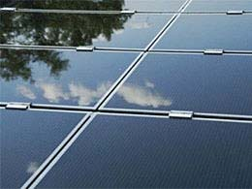
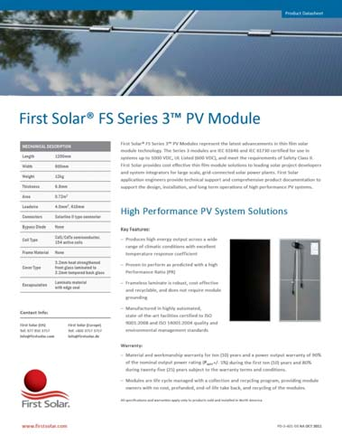

13.1.2 Thermal solar plant
A solar thermal plant will be built for the autonomous production of domestic hot water with natural circulation solar panels with boiler integrated within the structure made of stainless steel tubing. The solar panels will be placed on the flat roof and will fulfil more than 50% of the annual energy requirements for the production of domestic hot water.
The plant will be integrated with the apartment wall boiler suitable for the instantaneous production of domestic hot water. The preheated production system requires reinstatement only when the production of the solar panels is not sufficient.
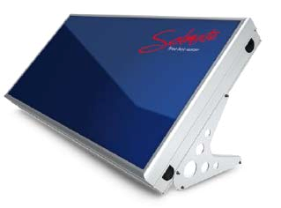

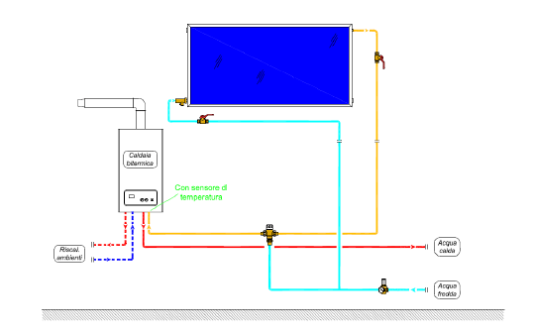

13.2. Mechanical systems
13.2.1 Heating system
The heating system will have towel warmer radiating elements of ZEHNDER Piastra type supplied with hot water produced by the wall independent boiler with 20 kW power and suitable also for the instant production of domestic hot water.
In the toilets, towel warmers of Zehnder type, Artea model, will be installed.

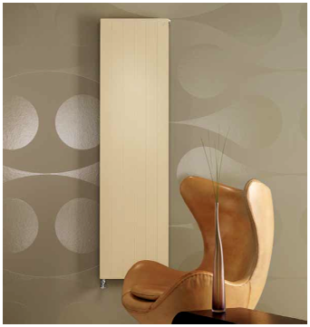
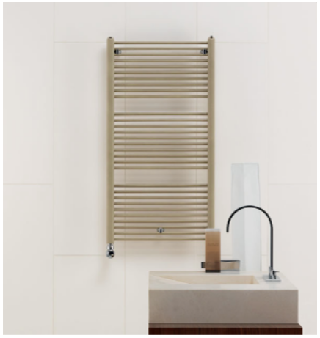

The adjustment of the internal temperature and of the turning on and off cycle (on a weekly basis and with two temperature levels within 24 hours) will be performed by the timer chrono-thermostat. Each radiating element will be equipped with thermostatic valve.
Domestic hot water will be produced by the centralized solar system and integrated with the aforesaid gas boiler by interposing a 5-connection solar valve suitable for securing the reinstatement only when the power production through the solar panel is not sufficient.

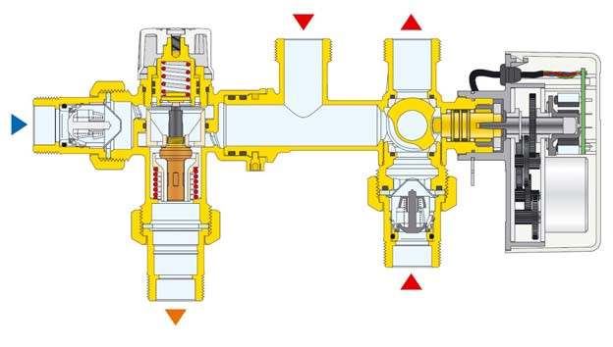

13.2.2 Air-conditioning plant
The gas pipeline will be arranged for the possible installation, to be done by the customer, of a summer air-conditioning system in every room, supposing a single external condensing unit capable of feeding multiple indoor units (a kind of multi-split).

13.2.3 Sanitary water system
The plant will be equipped with two condominium storage tanks for drinking water made of stainless steel and with a capacity of 1,000 litres each and with a pressurization group for the supply of sanitary utilities. The water used will be accounted for with an appropriate divisional counter of the property.
Distribution to bathroom suites will occur through distribution manifolds with multi-layer network of GEBERIT MEPLA type for drinking supply water of hot and cold individual utilities.
On the manifold it will be possible to intercept the supply of each individual utility served. The toilets will be equipped with bathroom suites of important companies and of high quality. The bathroom suites will be wall-hung and anchored to the wall with brackets equipped with anti-noise gasket. Each cellar will be equipped with water intake. The apartments with garden will be equipped with irrigation system.

13.2.4 Sewerage system
The drain system will be built with polypropylene coupling tubing up to the external collection and inspection wells. As the bathroom suites are wall-hung, the drains will all be wall drains. The cistern will be a double-button built-in wall cistern. The delivery network on the consortium dynamic manifold will be made with PVC tubing and before the delivery a drain well will be placed. Each cellar will be equipped with drain.

13.3. Electrical and special system

13.3.1 Grounding system
Each building will be equipped with ground plate system made of bare copper cable with a section of 35/50 mm2 and dispersion pile shoes. The equipotential bonding will be performed within the building in correspondence of the central premises.

13.3.2 Switchboards
Each apartment is equipped with its own General Switchboard from which the following lines will depart:
▪ Light line
▪ Plugs line
▪ Kitchen board supply line
- Technological room supply line
▪ Burglar alarm system supply line
▪ Air-conditioning system supply line
▪ Emergency light line

A board located in the kitchen will separate the main utilities such as refrigerator, oven, dishwasher, hob, washing machine, utility outlets. The device for the electrical loads control for power management will be installed. The apartments with garden will be provided with a line for external lighting supply and with the predisposition of a supply line for the irrigation system.

13.3.3 Lighting and FM system
Each room will be equipped with n. 1 ceiling light and n. 4 plugs. The kitchen will be equipped with n. 1 ceiling light point and n.6 plugs. The bedrooms will be equipped with central light control even from each bed station. The kitchen and the corridor will be equipped with independent emergency lighting units. The cellars will be equipped with light point and plug derived from the apartment counter.

All components and their plate will be white.

13.3.4 Burglar alarm system and automation
A volumetric and perimetric burglar alarm system will safeguard the property. The systems will be managed by multi-zone control unit with buffer battery. The installation of the plant will be done from inside in correspondence of the main access door or from the external connector. A GSM phone dialer will be installed.
The alarm will also be reported to the porter's desk. The opening/closing of the shutters will be automated and regulated locally through a single button.

13.3.5 Telephone system
Telephone system will be set up with a phone socket and a data socket for each room.

13.3.6 TV plant
A centralized TV system for digital TV with distribution via coaxial cable to the various properties. Each room, including the kitchen, will be equipped with TV plug. Cable connections for possible satellite dish will be arranged.

13.3.7 Video-entryphone system
The video-entryphone system will be implemented with external position in correspondence with the main entrance of the building and an internal position in the vicinity of the apartment entrance.

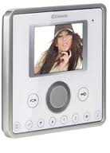

14. CELLARS AT DISPOSAL OF THE APARTMENTS
The cellar area of the apartments will be on the 1st basement floor of each building, which will be accessed directly from the stair and/or lift of the same building. The individual cellars will be aerated towards the respective interspace and closed with a door made entirely of galvanized steel. The cellar paving will be made of porcelain gres tiles. Lighting will be supplied through ceiling neon overhead lights.

15. MAIN ENTRANCE AND STAIRWELL
The gateway to the ground floor hall has been designed as for the drawing of the Designer in painted aluminum or wood with accident prevention glasses. The leaf will be equipped with special rubber gasket and adjustable spring for interiors. The stairs and landings of the properties will be covered with steps made of stone rise and tread or similar as for the designer's drawings.

During the floor laying stage, in the entrance hall on the ground floor and in correspondence of each apartment a flush-to-floor space designed to accommodate the mat provided by the manufacturer will be built. The lift plant floor will have similar finish, design and materials.

Entrance doormats of the apartments will be mandatorily uniform even after the delivery of the property, together with the umbrella stand of each floor.

The lighting system will consist in ceiling and/or wall overhead lights on the floors and low-consumption built-in spotlights (ceiling and/or wall) in the hall on the ground floor.

16. COMMUNAL GARDENS
The communal gardens will be equipped with irrigation and night lighting system, appropriately sized.

17. ROOF WATER COLLECTION
On the covering flat roof of every building a suitable sloping screed for the conveyance of water in the rainwater system has been built.
Drainpipes: in the points indicated by the Designer drainpipes will be installed outside the perimeter walls which will drain only rainwater. At the foot of each drainpipe an inspection well will be placed. The closing chimneys of the flues and exhaling ducts on the roof will be built as for the drawings according to the Designer's indications with properly isolated base.

18. SPECIAL NOTES
a) Villas and apartments will be built by including all the works, supplies, services and whatever else is considered to be necessary to complete each property internally and externally.
The following entries are excluded:
- Connection charges (electricity, water supply, gas mains and telephone network)
- Charges for the registration, notarial and cadastral charges
- All entries not specifically mentioned in this specification.
b) The characteristics of materials, construction details, etc.. are purely indicative; the Seller shall provide for the replacement of any component described with the use of materials and similar brands. In particular, the external and common areas such as facades, halls, etc.. will be built according to aesthetic and architectural choices which are up to the Seller and Designer. The Seller reserves the right to carry out, according to this document, changes to materials and technical solutions that are deemed useful and necessary for building and construction site requirements or for the supply of materials. Nevertheless, the commercial and performance value of

reference remains unchanged.
c) The arrangement of bathroom suites will be at the discretion of the Designer, as well as the location of the wall where the kitchenette will be placed, of the suction columns, the installation of flues and bins, the position of radiant elements, where applicable, and of any other system.
d) Each buyer is free to choose the materials as for the sampling proposed by the Seller and arrange the layout he/she wishes inside his/her apartment provided they comply with the instructions given by the Designer as stated in the previous paragraph b).
e) All that is required outside of these specifications will be considered extra and therefore counted as additional cost.
f) Changes with respect to the design drawings must be submitted to the Seller, who may, as a result of technical verification, not authorize them if they cause damage to the stability of the building or to the tranquillity of the other condominiums or if they are inconsistent with any other provision of law. It is however understood that all expenses for the changes implementation will be entirely borne by the Buyer, who will have to agree in writing (for both the quantity and the method of payment) with the Seller, prior to their execution. All the variants required by the Buyer and accepted in writing have bargaining power; therefore, if the buyer subsequently asks for its cancellation, the Seller shall retain a share of the amount provided for the works as compensation.
g) Any works of this specification that are not carried out by order of the Buyer will not be deducted. Cost differences related to the requests of the Buyer for the replacement of the finishing materials proposed in this document with superior quality products (flooring, interior coating, bathroom suites, etc..) must be agreed with the Seller and paid to him/her.

19. MANAGEMENT OF COMMON PARTS
The management of the common parts will be entrusted to a House Manager appointed by the Seller at the time of delivery of the residential units.

